Walk to Defeat ALS
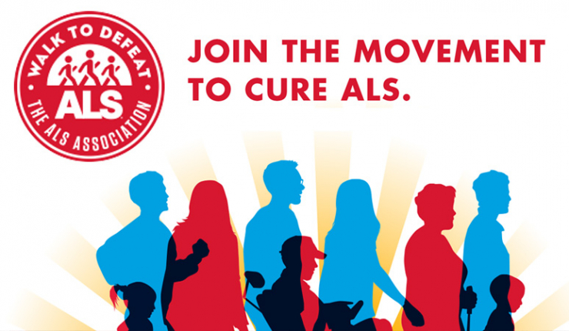
Every 90 minutes a person in this country is diagnosed with ALS and every 90 minutes another person will lose their battle against this disease. ALS can strike anyone.

Our friend, fellow skier, and former board member, Marianne Opilla was diagnosed with ALS in 2019. Join our team, SKIERS FIGHTING ALS, and walk 1 mile in her honor to raise awareness and funding to support patients, research, and treatments in our community.

October 23, 2021 9:00 AM
Brown’s Island, Richmond, VA
Team Captain: Joyce Parkey
To join SKIERS FIGHTING ALS, go to http://web.alsa.org/goto/RSC_Skiers_Fighting_ALS
If you have any questions, please contact Joyce at 804-304-3479 or jocasta68@gmail.com.
All donations no matter the amount are greatly appreciated, but any walker who raises $90 receives a t-shirt.

