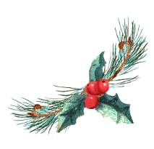
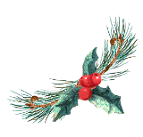
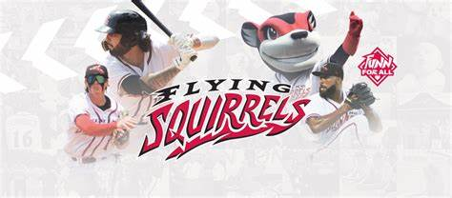
‘TIS THE SEASON TO CATCH FOUL BALLS!!!
Come out to the Diamond on June 7th and join your RSC friends for a special night of baseball!!!
Cheer on the home team, our very own Flying Squirrels, when they take on the Altoona Curves.

GAME HIGHLIGHTS: WINE AND K9’S: The first 1000 fans 21 and older will receive a Nutzy Wine Stopper. Enjoy $5 glasses of wine from New Kent Winery. The wine will be available at the Funville Fan Zone from 5:30 until 7:30.

TICKETS: We suggest that you purchase your ticket (s) ahead of time online. We will be sitting in General Seating behind the first base line.

SUGGESTED ARRIVAL TIME: 5:20pm – Gates open at 5:30pm (This will give you time to park and socialize at the Fan Zone and purchase a ticket if you did not buy it before June 7)
RSVP and send questions to:
Linda Neal: bodan3@yahoo.com or
Cynthina Stebbins: littlear1@yahoo.com

