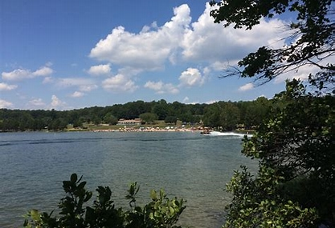
HIKING at LAKE ANNA
April 23 11:00AM
Join us at Lake Anna for a hike on the scenic Railroad Ford Trail. This 1.8-mile loop is located near Mineral. The historical trail provides lovely views of the lake as well as plenty of opportunities for bird watching and enjoying nature. It is a relatively easy walk. For the avid hiker, Lake Anna has other trails to be explored.
Additional information about the Railroad Ford Trail:
https://www.alltrails.com/trail/us/virginia/railroad-ford-trail
We will meet at the Visitor Center which is approximately a one- hour drive from Richmond. There is a $7 fee to park in the lot. You may want to carpool. TIME: Meet at 11:00 am
ADDRESS: 6014 State Park Lane, Spotsylvania Courthouse, VA 23551

OPTIONAL POST HIKE ACTIVITY:
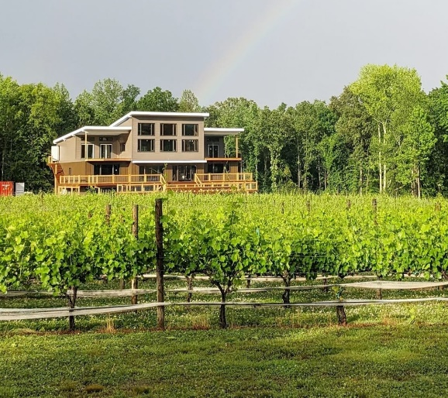
After the hike we will venture to Everleigh Winery. This family- owned boutique winery also features beer and cider. It is a short drive from Lake Anna and offers a beautiful setting as well as very good wines.
You are allowed to bring food so please pack a lunch, appetizer, or a snack to share with fellow hikers.
Everleigh Winery is located in Mineral and is on the way back to Richmond from the hike.
Address: 9845 Jefferson Highway, VA 23117
RSVP NO LATER THAN APRIL18: BODAN3@YAHOO.COM (Please indicate if you will be going to the winery post hike)

