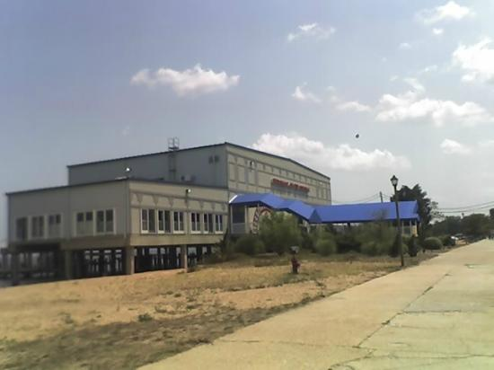
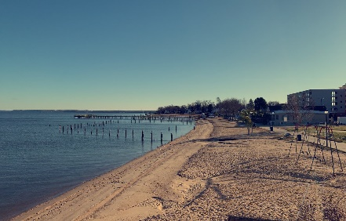
LIFE’s A BEACH/HIKE the POINT
SUNDAY, SEPTEMBER 11, 2020
VERY Easy 1 Hour Walk/Hike and Brunch
Meet at 10:15 AM - Walk 10:30 to 11:30 AM
Brunch – 12 Noon
Everyone welcome!

Park and meet at
Riverboat on the Potomac
301 Beach Terrace
Colonial Beach, VA 22443
Bring your walking shoes, sunscreen, water, and $$$ for your own brunch
At the Riverboat on the Potomac (Restaurant and Casino).
We will walk the entire point area, beside the Potomac River and then by Monroe Bay
for 1 hour, returning to the Riverboat by 12 noon for BRUNCH.
After BRUNCH as a group, you may spend the afternoon at the Casino,
on the beach or at the tiki bar or new Colonial Beach Brewery.
------------------------------------------------------
Contact Judy Marston –twoat1000@gmail.com – 804-332-3107 for more information.
LIFE’s A BEACH/HIKE the POINT
SUNDAY, SEPTEMBER 11, 2020
VERY Easy 1 Hour Walk/Hike and Brunch
Meet at 10:15 AM - Walk 10:30 to 11:30 AM
Brunch – 12 Noon
Everyone welcome!

Park and meet at
Riverboat on the Potomac
301 Beach Terrace
Colonial Beach, VA 22443
Bring your walking shoes, sunscreen, water, and $$$ for your own brunch
At the Riverboat on the Potomac (Restaurant and Casino).
We will walk the entire point area, beside the Potomac River and then by Monroe Bay
for 1 hour, returning to the Riverboat by 12 noon for BRUNCH.
After BRUNCH as a group, you may spend the afternoon at the Casino,
on the beach or at the tiki bar or new Colonial Beach Brewery.
------------------------------------------------------
Contact Judy Marston –twoat1000@gmail.com – 804-332-3107 for more information.

